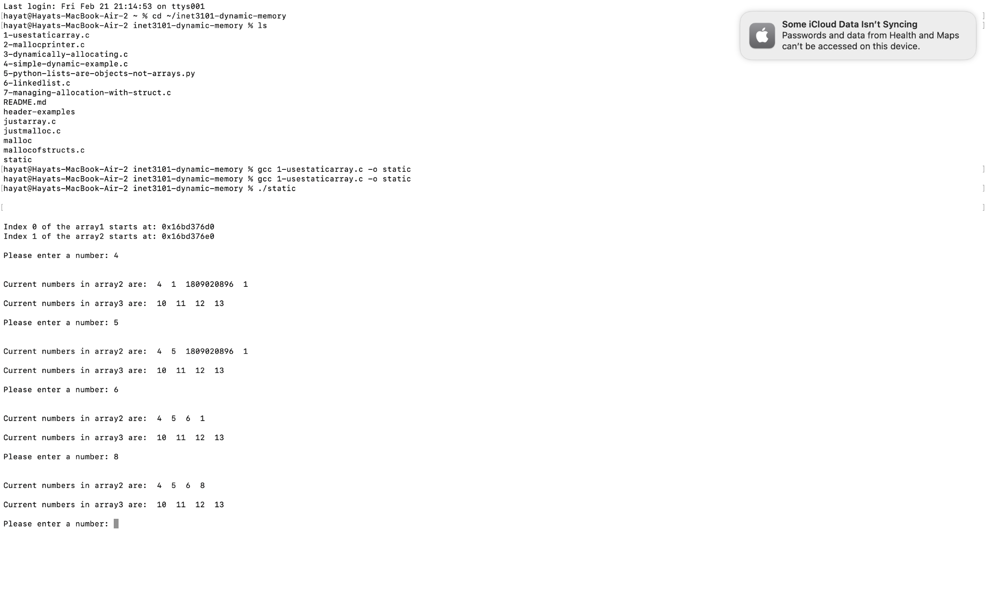

3) 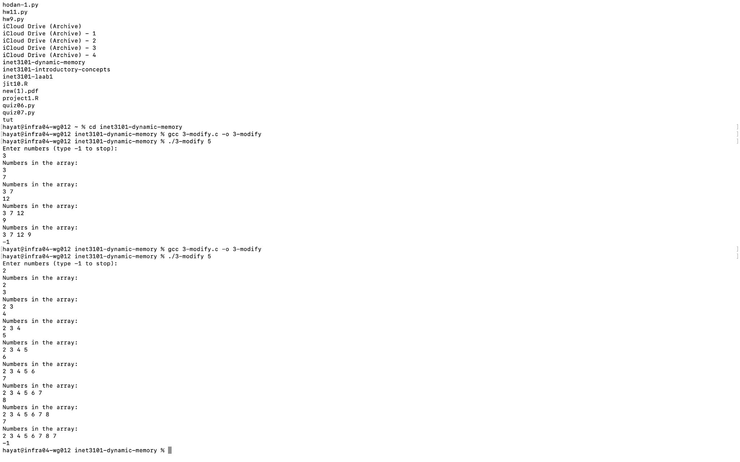

The program starts by allocating memory based on the user's input. It asks for numbers in a loop, and if the number of inputs exceeds the available space, it uses realloc() to double the array size to avoid running out of memory. This allows the programs to resume taking numbers without crashing. After each entry, it puts out the numbers, allowing the user to see what is recorded. The loop ends when the user enters -1, and the code frees the allocated memory to avoid memory leaks.

4) 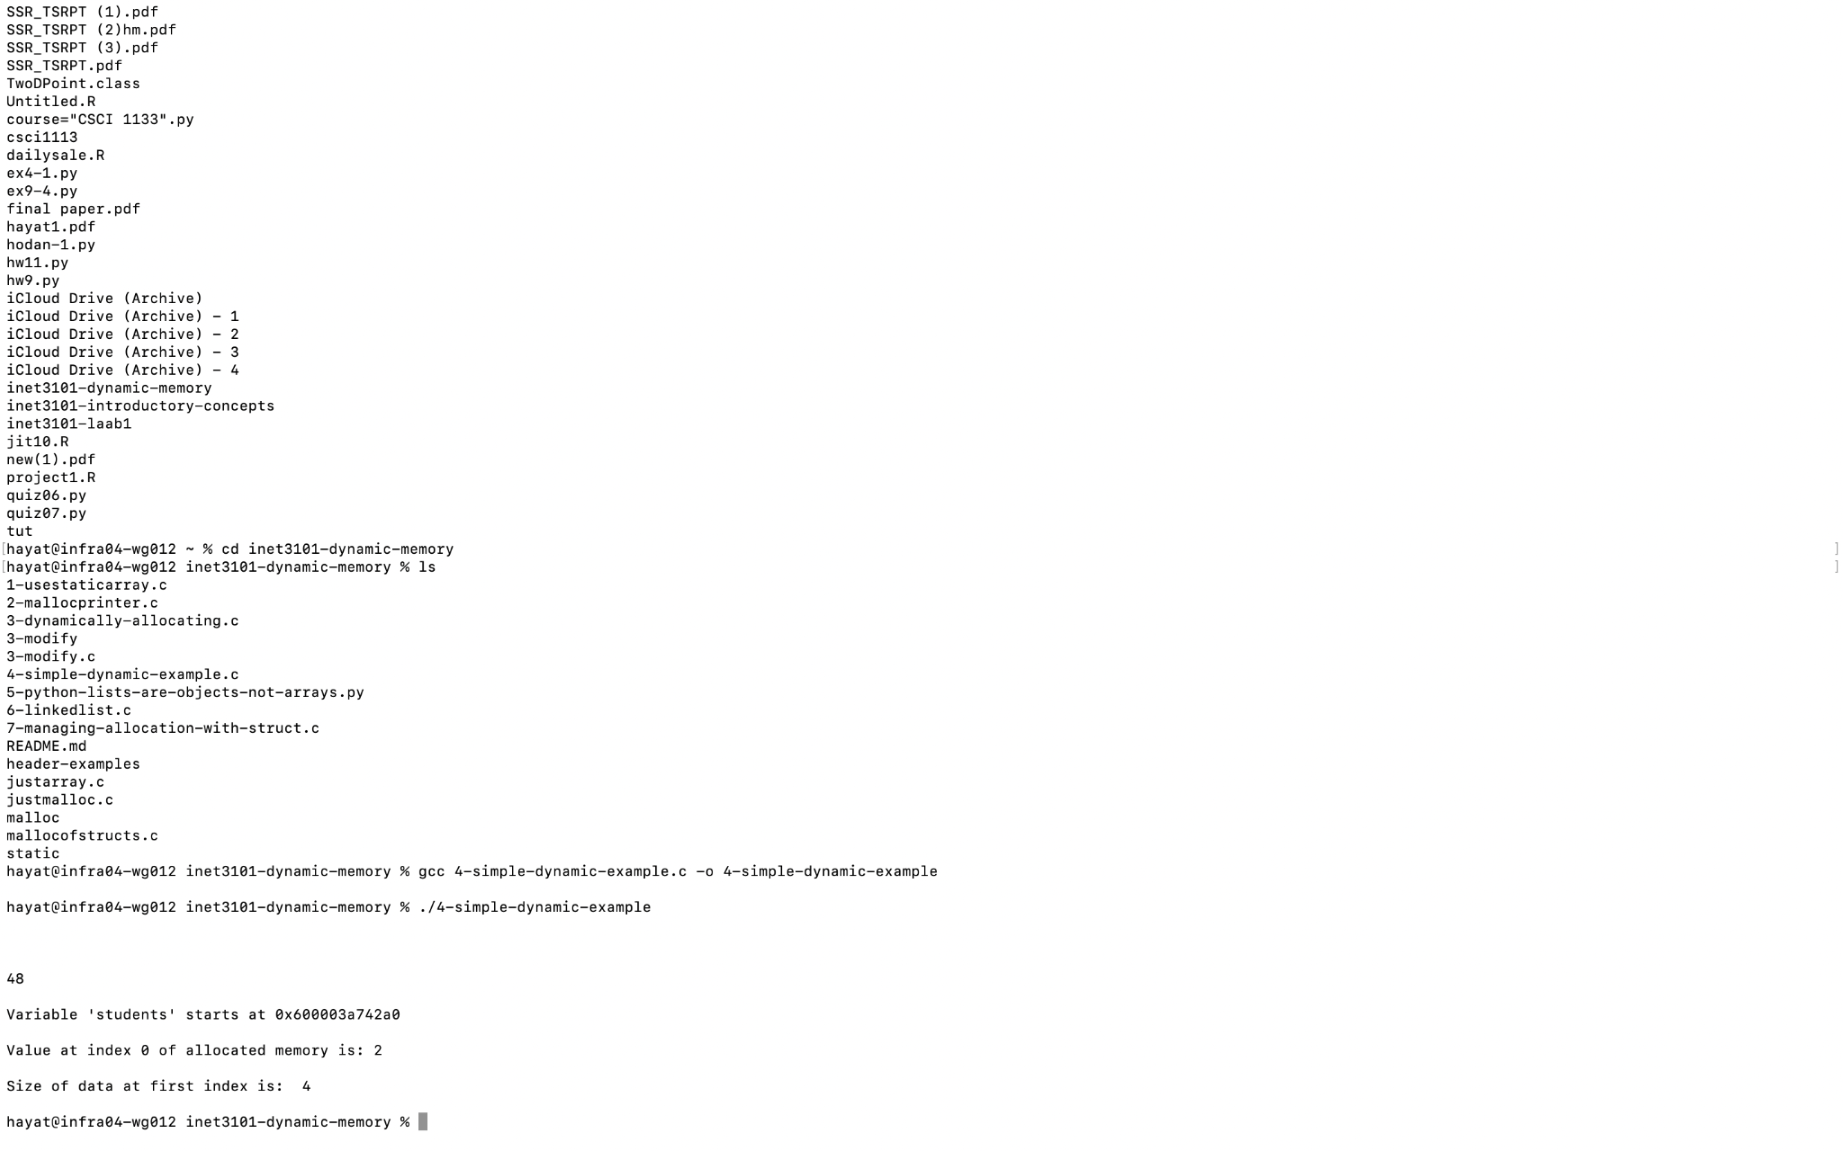

5) What is an Object in OOP?

* An object is defined as having both data (information stored) and functions. Objects are created from classes, which serve as blueprints for what the object should be and how it should function. Using objects saves programming since one can gather similar data and functions rather than creating separate code for each

How is a Python List an Object?

* A Python list is an object since it holds data (the list's items) and includes built-in functions for modifying the list, such as sort(), append(), and insert(). In C, changing the size of an array requires manually allocating new memory and moving data around. However, in Python, the list resizes automatically and handles everything for us. This makes Python lists far easier to use than C arrays.

6) A linked list solves dynamic memory issues by allowing for flexible development without requiring a set size. Unlike arrays, it keeps each element separately and connects them by pointers, eliminating the need to resize or relocate data. This allows adding and removing components, but it requires more memory for pointers and is slower to access elements than arrays.

Mallocfstucts:

